Setting parental restrictions on your child’s kit
- Tap (or click) the icon (Apple, Android, Microsoft, Xbox, Nintendo or Sony PlayStation) or scan the QR code with your phone’s camera
- Follow the instructions on the website exactly — in particular, setting the age of the child
- We recommend that you set the device to not allow any apps to be installed without your permission
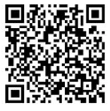
- Choose a strong password to protect your new settings —not the same as the unlockingcode!

