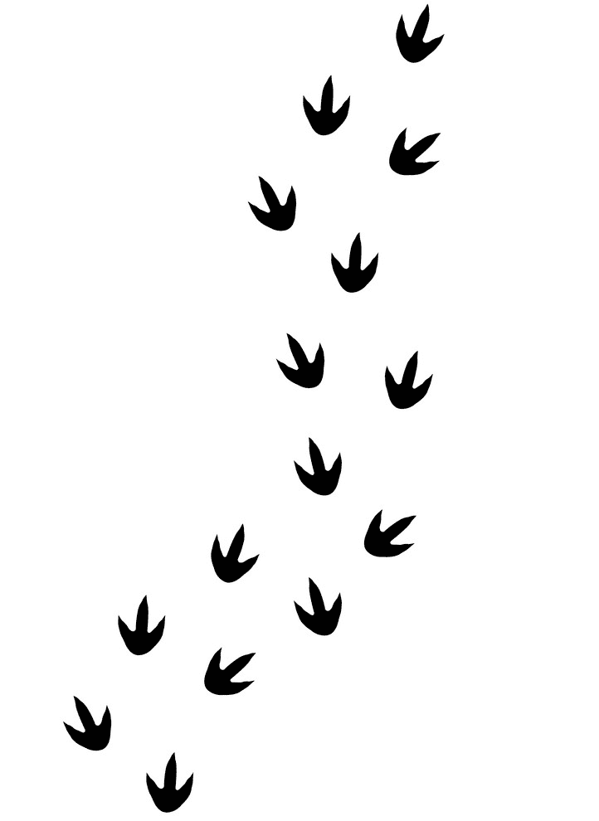

Quick as a flash…… number facts This half term we are focusing on finding one more or one less than numbers up to 50.
Topic
This half-term we are going to research significant individuals of the past, focussing on fossil hunters and palaeontologists, including Mary Anning. This links to our science work on animals. The children will explore how famous historical characters dramatically changed our understanding of dinosaurs and natural history. We will plot our history work so far this year on a timeline to understand when events occurred in history and think about the skills needed to be a palaeontologist.
English
This half term we will be using the book “Dinosaurs and All That Rubbish” to support our writing. We will continue to focus on saying our sentences out loud, using finger spaces, full stops and capital letters. We will use conjunctions to join sentences and adjectives to add interest. We will create a variety of written outcomes including letters, reports, setting descriptions, instructions, pamphlets, narratives and posters. We will edit and improve our work.
Maths
The children will be exploring numbers within 20 this half term, learning to read, write, order and represent them. The children will move on to adding and subtracting within 20, developing understanding of place value and what the numbers really mean in numbers over 10. The children will be encouraged to recall their number bonds to 10 and apply them with number bonds to 20 - observing patterns and links between the numbers. We will continue to focus on correct formation of numbers and spelling numbers 0-20 in words.
Phonics
Phonics will be taught daily as a whole class session. This half term we will continue to learn alternative sounds. We will also embed known sounds and practise reading and writing tricky and polysyllabic words. Please continue to look for the sounds and tricky words we have been learning in your child’s own reading book and books you read to them.
Handwriting
The children will continue to practice individual letter formation by sky writing and in their handwriting books.
Reading
We will explore quality texts each week during English including shared reading which will support your child to fully explore and understand aspects of the text which may not be obvious. Please encourage your child to share other books at home with you, which they may not be able to read for themselves, this will expose them to new vocabulary. Your child should be reading their phonics book to you every day for around 10 minutes, this will develop recognition, fluency, expression and confidence.
Spring Term 1
Who left that footprint?
Art and Design
We will look at different pieces of art by Paul Klee and explore sketching and drawing techniques. We will explore hot and cold colours in art. We will experiment with mark making and make clay ammonite fossils.

Computing
We will explore the importance of remaining safe when using computers and thinking about information that we share. We will learn what an algorithm is through coding sessions and research our topic using ‘Kiddle’.

PSHE
We will continue to take part in bi-weekly circle time meetings where we share our thoughts on school values, rules and charities. In class we will think about our goals for the year ahead and what areas we would like to improve in our academic and personal life, and how to keep ourselves fit and healthy. We will also consider how we can help our planet to stay healthy too. Other learning will include Birdwatching Day and Fairtrade Fortnight?.

Values We will explore and celebrate our values throughout our learning- being curious, resilient, courageous, kind, caring respectful and fair.

Outdoor Learning - We will use the outdoors in all areas of the curriculum. We will be exploring our school’s grounds and picking different areas to use for our seasonal change investigation. We will ensure our garden area is kept tidy during the winter months. Forest school will continue weekly on Tuesdays.

PE
Dance and gymnastics will be the focus of PE lessons this term, the children will develop their gymnastic routines by using tablets to video themselves, reflect on and then improve.
RE
This half-term our focus will be on Judaism, the children will learn about significant objects, places and celebrations important to Jewish people. We will visit a synagogue.
Science
Animals Including Humans
We will begin our research by exploring animals and thinking about how to sort them based on what we already know. We will then explore their different physical features, diet and habitat to understand how animals can be grouped. We will also think about how important habitats are to animals and the impact that humans have on the environment.
Seasonal Changes
Over the year we will observe how our environment changes through the seasons; monitoring the weather, length of day, temperature, rainfall and how the trees look.

Music
We will be following Surrey’s interactive scheme Charanga, this half term looking at pitch and rhythm.
Show and Tell
We will continue to have a Squirrel Star each day, please help your child to think of 3 clues to describe what they have to show, when it is their turn.

