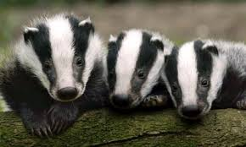
Badger’s spellings and tables.
w/c 27th February 2023 |  |  | w/c 6th March 2023
copier  copied  happier  happiest  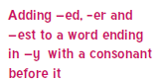  cried  replied  people  bath  plant  path | 100÷10=10  90÷10=9  80÷10=8  70÷10=7  60÷10=6  50÷10=5  40÷10=4  30÷10=3  20÷10=2  10÷10=1 |  | copying  crying  replying  flying  trying  carrying  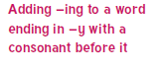  father  class  last  fast | 0x5=0  1x5=5  2x5=10  3x5=15  4x5=20  5x5=25  6x5=30  7x5=35  8x5=40  9x5=45  10x5=50
w/c 13th March 2023 |  |  | w/c 20th March 2023
hiking  hiked  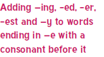  hiker  nicer  nicest  shiny  being  grass  pass  everybody | 50÷5=10  45÷5=9  40÷5=8  35÷5=7  30÷5=6  25÷5=5  20÷5=4  15÷5=3  10÷5=2  5÷5=1 |  | patting  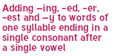  patted  humming  hummed  dropping  dropped  sadder  saddest  runner  runny | 0x3=0  1x3=3  2x3=6  3x3=9  4x3=12  5x3=15  6x3=18  7x3=21  8x3=24  9x3= 27  10x3=30
w/c 27th March 2023
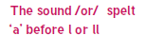  all  ball  call  walk  talk  always  great  wild  water  beautiful |  | 30÷3=10  27÷3=9  24÷3=8  21÷3=7  18÷3=6  15÷3=5  12÷3=4  9÷3=3  6÷3=2  3÷3=1

Dear Parents,
This term in Badger Class we are continuing to learn our spelling rules.
In addition to the weekly spellings we have also included multiplication and division facts to learn this half term It will be really beneficial to your child if they could learn these multiplication and division facts in order to support their maths work (they will be tested in a random order).
Our tricky words are highlighted in blue and are taken from the Year 2 Common Exception Word list. These are words which don’t follow the patterns and need to be learnt by heart.
The children will have an informal spelling and times table quiz at the end of each week. Any help you can give your child to learn these words will certainly help them. We thank you in advance for your support with this.
The Badger Class team

