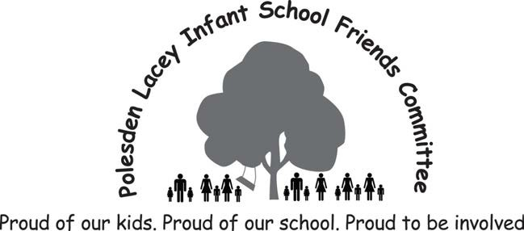

FRIENDS NEWS
Friends of Polesden Lacey Infant School Summer Newsletter

Thank you to everyone who has donated and taken part in all of our spring fundraising activities. As previously mentioned the quiz, cake sale and sponsored bounce were all great successes! If anyone still needs to send in their sponsor forms please do leave them with Mrs Scott. Through our fundraising this year, we have been able to provide funds for a new school noticeboard which will be appearing in the coming weeks, as well as donations to school workshops and a new trim trail!

The summer term sees the Friends take part and hold two important community and fundraising events. Firstly Village Day on 15th June, where the Bookham community comes together to support local causes and businesses and is a great opportunity for the children to celebrate and showcase our lovely school. Secondly our annual Summer Fair taking place on 7th July, details on both to follow below. As the sun comes out and summer (hopefully!) appears, we do hope that you and your families will join us in these events this term.

Key Dates
12th June - Friends Meeting (all welcome) 14th June - Making Morning for Village Day 14th June - Bunting Competition Deadline 15th June - Village Day
28th June - Mufti Day & Summer Fair Toy, Bottle, Jolly Jar Collection 7th July - Summer Fair

Bookham Village Day

Saturday 15th June

Bookham Village Day is fast approaching, with the date set for Saturday 15 June. For new parents who may not have heard of Village Day, it is a great community get together with the main event being a themed costumed parade through the village by the local infant schools. The children and parents alike love it and it is a really fun day for everyone at the school.

This year’s theme is ‘Under the Sea’. Being true to Polesden’s Eco School roots we are sending an environmental message with our costumes this year. The theme for our costumes is ‘Swimming in Plastic’. The children will be dressed as divers with sea animal banners, recycled plastic streamers and fishing nets filled with plastic items (all of which will be recycled after the parade).

On the day it would be great if the children could please wear their school PE kit or similar (kits will be sent home with children on Friday 14 June along with their costumes). If you have a snorkel, goggles or sunglasses they can wear it would also add to their outfit, and be extra dressing up fun for the kids!

The children will also be singing a song as we march along. They will be learning this in class, but if you’d like to practice at home the words are below and the song this is based on can be found here: https://m.youtube.com/watch?v=60XJblVEyA8

All the fish are swimming in the plastic Swimming in the plastic Swimming in the plastic
All the fish are swimming in the plastic Bubble, bubble, bubble, bubble ...SPLAT!

Donations Needed

To make the costumes for our theme 'Swimming in Plastic', we need 90 x 2 litre plastic bottles to make our divers’ air tanks.
There is a collection box for these outside the office - please help if you can!

Summer Fair

Sunday 7th July

We are looking forward to our Summer Fair on Sunday 7th July from 12pm till 2pm. We hope that as many of you as possible will be able to get involved with this fantastic annual school event. There will be a BBQ, local Gray's gelato, bouncy castles, obstacle courses, plenty of games and lots more. Please take a moment to read below how you can help in the build-up to the Fair, and make a note of the key dates. Thank you!

Toy Donations
We will be collecting pre-loved toys and books for the Toy Stall at the Fair. Please leave your clean and complete contributions, suitable for ages 4 to 7, in the box which will be outside school after half-term.

Raffle
Look out for raffle tickets in the book bags in June. We have some fantastic prizes on offer, including dance classes, private yoga sessions, beauty prizes and family day passes to Hobbledown, Bocketts Farm, Little Street - perfect for the school holidays, plus many more... so it's well worth getting involved!

Mufti Day
We will hold a mufti day on Friday 28th June. Children may wear their own clothes in exchange for bringing in a bottle (alcohol preferred if possible), a clean, pre-loved soft toy and a jolly jar (decorated jam jar filled with wrapped sweets). All these items will be used on stalls at the fair and make a huge contribution to the success of the day, so thank you in advance for your support.

Bunting Design Competition
Instead of the usual poster competition, this year we are asking the children to design individual flags with a Summer-y theme for some bunting to decorate the Fair. All children will have the opportunity to decorate a flag during school time, however we encourage them to do more at home if they would like to. The deadline is Friday 14th June and flags will be available from school shortly. There will be a prize for the best flag in each class!

Gazebos
If you have a gazebo that we could borrow for the Fair (either to protect us from hot sun or light showers!) please let Mrs Scott know.

We need your help!

Making Morning Volunteers Friday 14th June
To whip up our wonderful costumes for Village Day we need 10 helpers for our making morning on Friday 14th June - if you would like to help please contact Emma Adler from Squirrels on 07881785634 or emmacadler@gmail.com Please note: to take part in this morning, you will have needed to complete Mrs
Keedy's Safeguarding briefing, for further details on this please contact Mrs Scott.

Summer Fair Volunteers Sunday 7th July

Our Fair depends on parents, grandparents, older siblings etc donating a little bit of time to run the stalls during the event. A sign up sheet will be put outside school a couple of weeks before the day itself. Please sign-up for a session on a stall to make sure we can keep all stalls open throughout the Fair.

Autumn 2019 onwards

All of our fundraising activities are only possible with a great group of volunteers, parents, pupils and family members alike. If you would like to be involved in any of the above, have a great idea for fundraising for next year or would like to come to the next committee meeting - 12th June for a making and meeting evening, then please do get in touch.
Thea Phillips phillips.thea@gmail.com 07866622286

